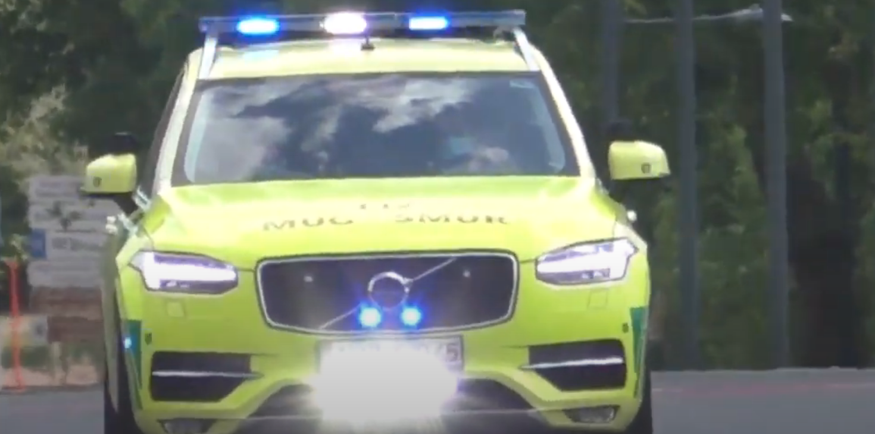

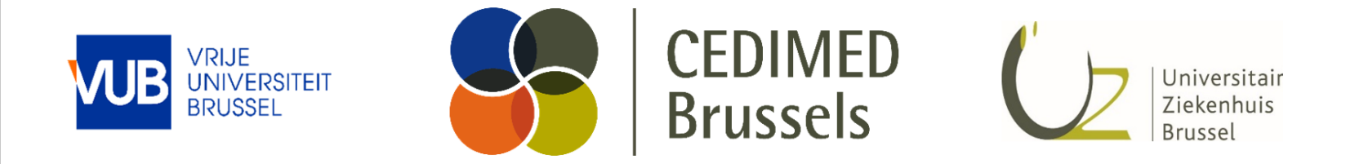

Webdesign

Basisteksten

Webdesign

Base text

**Colophon**

This is a publication by

CEDIMED Brussel

Laarbeeklaan 101, 1090 Jette (Brussel)

www.cedimed.brussels

© 2024, CEDIMED Brussel

**Authors**

# **Contents**

Contents 5

1 CEDIMED Brussels 6

1.1 Menu structure 6

1.2 Landing page 6

1.2.1 Title & Slogan 6

1.2.2 Link text to pillars 6

1.2.3 About Us 6

1.2.4 Contact us 8

2 PIllars 9

2.1 Clinical pillar – Emergency department 9

2.2 Educational pillar 10

2.3 Research pillar – ReGEDiM 10

2.4 Innovation pillar 11

# CEDIMED Brussels

## Menu structure

* Landing page
* About Us
  + Vision and mission
  + Our team
* Contact US

## Landing page

### Title & Slogan

Titel : Centre for Emergency & Disaster Medicine Brussels

Slogan : Leading the Future of Emergency and Disaster Medicine: Where Practice, Education, Research, and Innovation Meet.

### Link text to pillars

#### Clinical care

Discover how we provide fast, efficient, and patient-centered care that ensures continuity and directly addresses urgent medical needs.

#### Education

Discover our practice-oriented and internationally recognized programs, supported by top instructors and groundbreaking research.

#### Research

Explore our interdisciplinary research that tackles societal challenges and enhances care and education.

#### Innovation

Experience how our innovative solutions respond to the needs of patients and healthcare providers, contributing to sustainable healthcare.

### About Us

#### About CEDIMED Brussels

At CEDIMED Brussels, we are committed to pioneering work and excellence in emergency and disaster medicine. Our mission is clear: to provide high-quality care, promote education, stimulate research, and embed innovation in all our activities.

**Our mission**

We see a future in which CEDIMED Brussels sets the standard in emergency and disaster medicine, both in Belgium and internationally. By integrating clinical practice, research, and education, we strive to continuously improve and innovate healthcare. Our commitment goes beyond medical care. We aim to play a key role in promoting a sustainable and inclusive society.

**Our mission**

Our mission is rooted in providing accessible, efficient, and human medical care. We are committed to improving the quality of life for our patients, regardless of their background or beliefs. By combining human dignity with advanced medical expertise, we create an environment where innovation thrives and where the healthcare professionals of tomorrow are trained and inspired.

**What we do**

CEDIMED Brussels offers a wide range of services to support both patients and the broader healthcare system:

* **Clinical Care:** Our UZ Brussel team provides 24/7 emergency medical services, focusing on personalized treatments and efficient coordination of complex care pathways. We ensure rapid interventions both inside and outside the hospital and are ready to respond in crisis situations and disasters.
* **Education and Training: As a university hospital, we are deeply involved in training healthcare professionals through advanced simulations and internationally recognized training programs.**
* **Research:** Our research group ReGEDiM is at the forefront of developing new treatments and technologies that enhance healthcare and advance the field of emergency medicine.
* **Innovation:** In an ever-changing world, CEDIMED Brussels is strongly committed to innovation. We develop sustainable, innovative healthcare solutions and work closely with the industry to drive technological advancement. In this way, we play an important role in improving healthcare and preparing for the challenges of future care.

**Our commitment to excellence**

Excellence is at the heart of everything we do. We continuously strive to achieve and exceed the highest standards in healthcare, supported by a solid internal structure that guarantees efficiency, flexibility, and high-quality service.

At CEDIMED Brussels, we believe in the power of collaboration, both locally and internationally. Our partnerships with academic institutions, healthcare providers, and industry keep us at the forefront of healthcare, ensuring that our work has a lasting impact on both the healthcare sector and society.

**Together shaping thefuture**

With our constant commitment to care, education, research, and innovation, CEDIMED Brussels is ready to tackle the challenges of today and tomorrow. Together, we can build a healthier and more resilient future.

### Contact us

#### Contact form

Content:

* Contact details of the submitter:
  + Compulsory:
    - First Name
    - Last Name
    - Email
  + Optional
    - Phone Number
* Subject via dropdown list (compulsory):
  + General Inquiry
  + Clinical care
  + Education
  + Research
  + Innovation
* Message Window (compulsoryt)

Send to: info@cedimed.brussels

#### Map and Address

* Full address, general phone number, fax, email
  +  Laarbeeklaan 101, 1090 Jette
  +  02 477 51 00
  +  02 477 51 68
  +  info@cedimed.brussels
* Enclosed Google Maps, with the option to plan a route.

# PIllars

## Clinical pillar – Emergency department

Title: Clinical Care at UZ Brussel

**Emergency Care in the Hospital**

At UZ Brussel, the Emergency Department is ready to provide urgent care 24/7. We distinguish three types of care: primary care, secondary care, and complex tertiary care. Where possible, we refer patients to primary care, but our role in secondary care remains essential. The core of our emergency care is focused on the following principles:

* **Personalized Care:** The patient is central and actively involved in his or her care process.
* **Efficient Coordination:** We ensure smooth patient flow and coordinate admissions and referrals for urgent patients across various disciplines.
* **Somatic and Mental Health Care:** Both physical and mental health are given attention, with diversity and multiculturalism considered as valuable assets.
* **Always Ready** Our service is available 24/7 for medical emergencies and reanimations.
* **Crisis Management:** We play a key role in developing and implementing internal emergency plans.
* **Flexible Organization:** Our team can quickly transition to complex tertiary care without interrupting our secondary care responsibilities.

**Prehospital Care**

Our expertise extends beyond the hospital. Through our EMT and Paramedic intervention team, we provide urgent medical assistance outside the hospital, in collaboration with the emergencycenter 112.

**Interhospital Care Provision**

We support other hospitals by transporting critical patients between facilities. We do this with a high-tech ambulance and a specialized transport team, supported by internal and external medical experts.

**Disaster Medicine**

Our emergency department provides medical assistance in disaster and crisis situations, both inside and outside the hospital. We send out coordinating teams and deploy additional medical resources where needed. Preventive medical support at large events is also part of our service offering.

## Educational pillar

Titles: Training and Development at CEDMIED Brussels

At CEDIMED Brussels, we are committed to the training and professional development of healthcare providers. As a university center<we play a crucial role in training healthcare providers, nurses, doctors, and other healthcare professionals.

**Internal Training**

Our internal training programs are at the core of our training policy. We combine traditional methods with simulation training, focused on rare but critical situations, to ensure the highest quality of care.

**External Training**

Together with the Faculty of Medicine and Pharmacy at VUB, we support training in emergency medicine and clinical education. In addition, we collaborate with institutions such as PIVO for the training of emergency responders and paramedics.

**Training Center**

Our training center offers a range of internationally certified courses , such as Advanced Life Support (ALS), European Trauma Course (ETC) and Safe Transfer and Retrieval (NAPSTAR). Thanks to our experienced team and efficient organization, we guarantee top-quality training.

## Research pillar – ReGEDiM

Title: ReGEDiM - Research Center for Emergency and Disaster Medicine

ReGEDiM, the Research Center for Emergencyand Disaster Medicine, was established in 2011 as part of the Vrije Universiteit Brussel (VUB). The center evolved from an earlier research initiative on disaster medicine that was established in 2008. ReGEDiM also organizes the European Master in Disaster Medicine (www.dismedmaster.com).

**Research at ReGEDiM**

Our research program focuses on various aspects of emergencyand disaster medicine:

* **EmergencyMedicine:** We conduct research on training, quality improvement, IT solutions, data management, process analysis, predictors of care outcomes, reanimation, developments in medical imaging, patient satisfaction, and care for geriatric and pediatric emergency cases.
* **Disaster Medicine** The focus here is on evidence-based disaster medicine, disaster modeling and simulation, disaster management, mental health in disaster situations, and ethical issues in disaster response.

**Innovation and Applications**

ReGEDiM also focuses on practical applications of its research findings, such as:

* Utstein-style Template: A standardized template for uniform reporting of acute medical assistance in disaster situations.
* ISEE OnScene™ and In-Hospital™: Software programs for education and training based on simulated disaster patient scenarios.
* CrisisData©: A universal medical record for disaster situations, based on scientific evidence.
* DEMIS©: IT solutions for emergency and disaster medicine.
* SIMEDIS©: Simulations for enhancing medical disaster management.
* Mathematical tools for logistical decision support in acute medical assistance.

Through these initiatives, ReGEDiM actively contributes to the improvement of emergencyand disaster medicine worldwide.

## Innovation pillar

At CEDIMED Brussels, innovation is the driving force behind improvements in healthcare. Our mission is clear: we aim to make healthcare safer, better, and more affordable through innovative solutions. This is realized by collaborating with research institutions and industry, and by developing sustainable products and processes that contribute to advancements in the healthcare sector.

**Innovation forbetter healthcare**

Our mission is to continuously improve the quality and safety of healthcare. We focus on innovative techniques and processes that promote the health and well-being of patients, while ensuring the affordability of healthcare. In a changing world, we continue to innovate, collaborating both internally and with external partners to create innovative solutions for today’s challenges.

**Pioneering in healthcare innovation**

CEDIMED Brussels aims to be a pioneer in healthcare innovation. Our vision is focused on developing new technologies and processes that enhance the quality of care. By translating our expertise into innovative solutions, we aim to create a resilient, patient-centered healthcare environment that is ready for the future. We focus on building strong collaborations between healthcare providers, researchers, and the industry to make a lasting impact on healthcare together.